TASK 1

void delay_ms(uint32_t ms){
__HAL_TIM_SET_COUNTER(&htim2, 0);
HAL_TIM_Base_Start(&htim2);

while (__HAL_TIM_GET_COUNTER(&htim2) < ms);

HAL_TIM_Base_Stop(&htim2);
}

while (1)
{
HAL_GPIO_WritePin(GPIOE, GPIO_PIN_9, GPIO_PIN_SET); // RED LED ON
delay_ms(1000);

HAL_GPIO_WritePin(GPIOE, GPIO_PIN_9, GPIO_PIN_RESET); // RED LED OFF
delay_ms(1000);
}

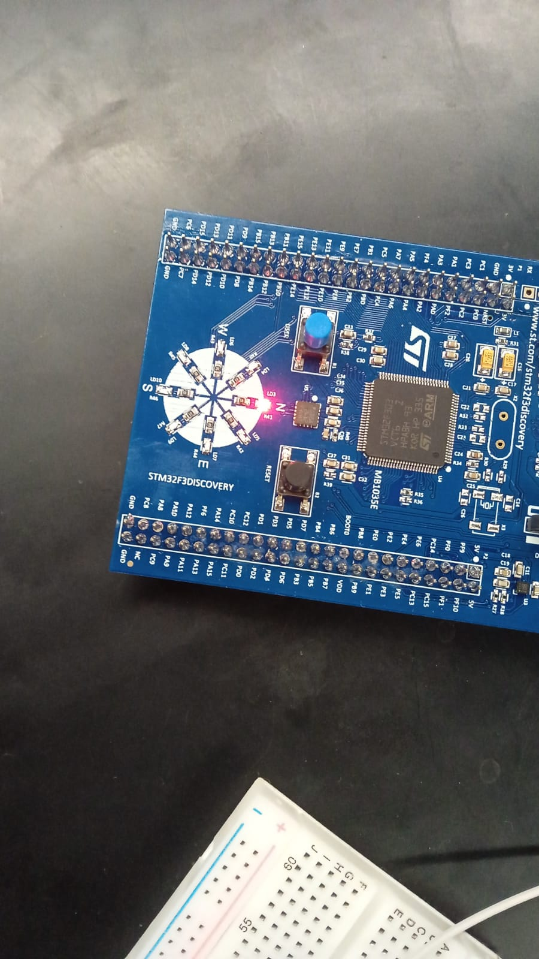

TASK 2
CODE:
//TASK 2
void HAL_TIM_PeriodElapsedCallback(TIM_HandleTypeDef *htim)
{
if (htim->Instance == TIM2)
{
HAL_GPIO_TogglePin(GPIOE, GPIO_PIN_9); // Red (North) LED
}
}
HAL_TIM_Base_Start_IT(&htim2);

/* USER CODE END 2 */

/* USER CODE BEGIN WHILE */
while (1)
{
/* USER CODE END WHILE */

/* USER CODE BEGIN 3 */
}

OUTPUT:
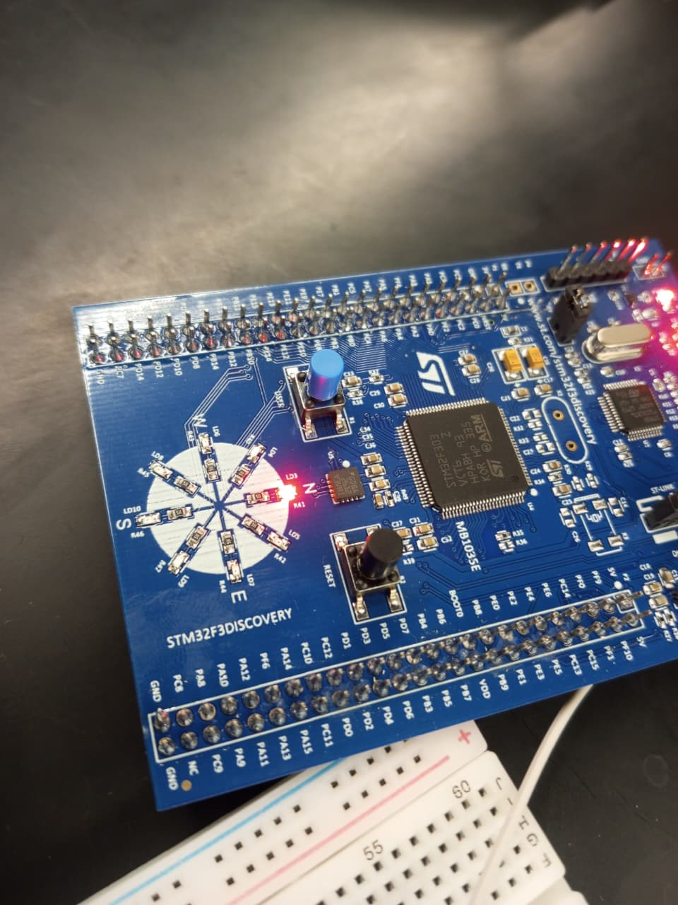

TASK 3:
CODE:
/* -------------------- TASK 3------------- */
void HAL_TIM_PeriodElapsedCallback(TIM_HandleTypeDef *htim)
{
if(htim->Instance == TIM2)
{
// Increment software counters
countA++;
countB++;
countC++;

// LED1: PE9 (Red)
if(countA >= THRESHOLD_A)
{
HAL_GPIO_TogglePin(GPIOE, GPIO_PIN_9);
countA = 0;
}

// LED2: PE10 (Green)
if(countB >= THRESHOLD_B)
{
HAL_GPIO_TogglePin(GPIOE, GPIO_PIN_10);
countB = 0;
}

// LED3: PE11 (Blue)
if(countC >= THRESHOLD_C)
{
HAL_GPIO_TogglePin(GPIOE, GPIO_PIN_11);
countC = 0;
}
}
}
}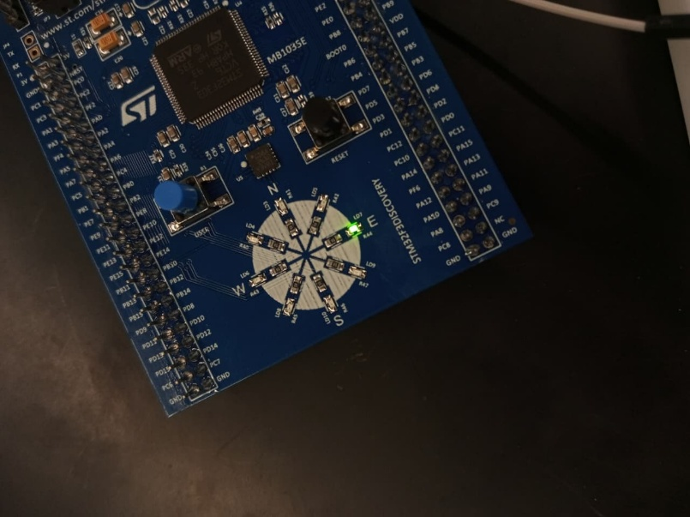

TASK 4:

CODE:
void HAL_TIM_IC_CaptureCallback(TIM_HandleTypeDef *htim)
{
if(htim->Instance == TIM3)
{
if(htim->Channel == HAL_TIM_ACTIVE_CHANNEL_1)
{
// Read the captured value
uint32_t current_capture = HAL_TIM_ReadCapturedValue(htim, TIM_CHANNEL_1);
// Calculate period (handle overflow)
if(current_capture >= last_capture)
{
period = current_capture - last_capture;
}
else
{
// Timer overflow occurred
period = (0xFFFF - last_capture) + current_capture + 1;
}
// Update last capture value
last_capture = current_capture;
// Calculate frequency
// Frequency = Timer_Clock / [(Prescaler + 1) × Period]
if(period > 0)
{
frequency = (float)TIMER_CLOCK_FREQ / ((float)(TIM3_PRESCALER + 1) * (float)period);
valid_measurement = 1;
}
// Reset overflow counter
overflow_count = 0;
}
}
}

OUTPUT:
At 100K
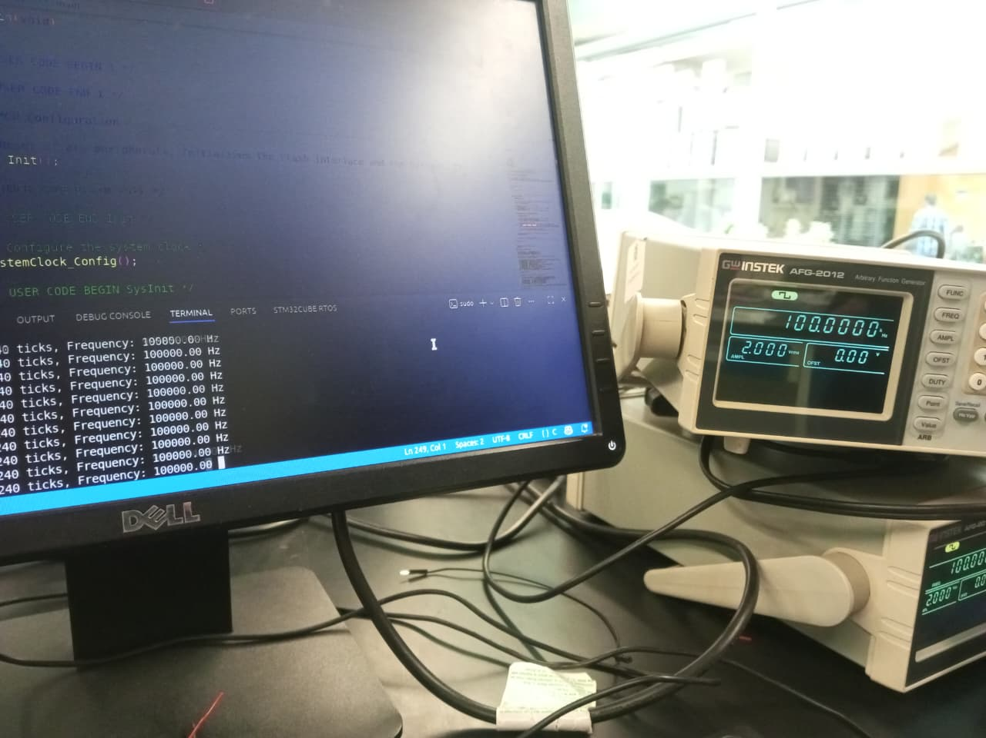

AT 20K:
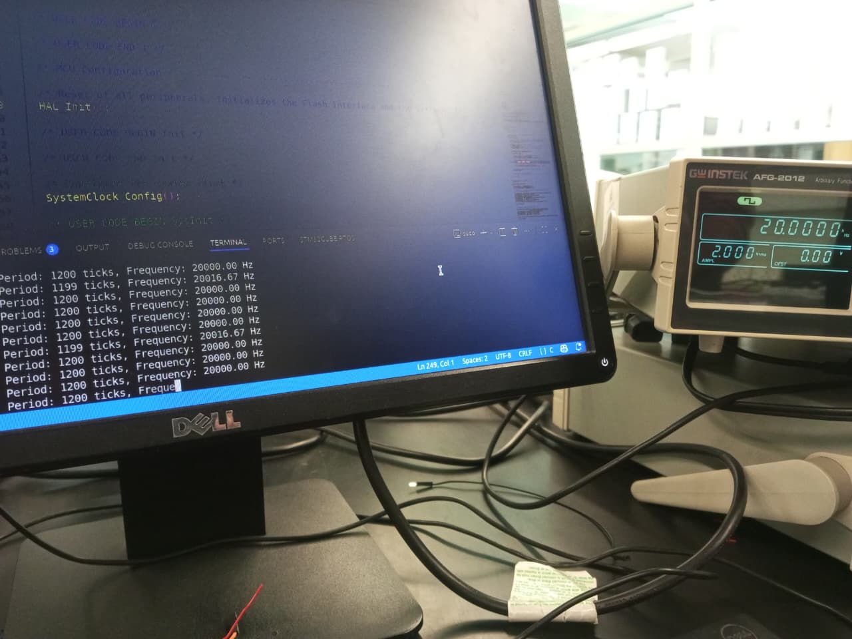

Calculations:
1. Timer Clock Configuration
Base Clock Calculation:
System Clock = 8 MHz
PLL multiplier = 6
System Clock after PLL = 8 MHz × 6 = 48 MHz
APB1 Clock = 24 MHz
Timer Clock Frequency:
APB1 Timer Clock = 48 MHz
TIMER_CLOCK_FREQ = 48,000,000 Hz
2. TIM3 Configuration
From the code:
Prescaler = 1;

Effective Timer Clock:
Effective Timer Frequency = CLOCK_FREQ / (Prescaler + 1)
= 48,000,000 / (1 + 1)
= 48,000,000 / 2
= 24 MHz = 24,000,000 Hz

Timer Resolution:
Timer Tick Period = 1 / 24,000,000 Hz
= 0.04167 μs
= 41.67 ns

3. Frequency Calculation Formula
From the code:
frequency = CLOCK_FREQ / (PRESCALER + 1) * period);

Simplified:
Frequency = 48,000,000 / (2 × period)
= 24,000,000 / period Hz

4. Example Calculations

Example 1: 1 kHz Input Signal
Input Signal Period = 1 / 1,000 Hz = 1 ms = 0.001 s
Number of Timer Ticks (period) = 0.001 s / (1 / 24,000,000)
= 0.001 × 24,000,000
= 24,000 ticks

Measured Frequency = 24,000,000 / 24,000
= 1,000 Hz = 1 kHz

